**AI-Powered Sales Forecasting Dashboard**

**Overview**

This repository contains all files and documentation for Task 1 of the Future Interns Machine Learning Internship (December 2025). The goal is to build a dashboard that predicts future sales trends using historical retail sales data.

**Project Structure**

* **SuperStore_Sales_Dataset.csv:** Raw sales data used for analysis and modeling.
* **prophet_model.ipynb:** Python script implementing the sales forecasting model with Prophet.
* **forecast_results_final.csv:** Output file containing model forecast results.
* **requirements.txt:** List of Python libraries and versions needed to run the code.
* **task1phb.pbix:** Power BI dashboard visualizing actual and forecasted sales trends.

**Approach**

* Performed data preparation and cleaning on the retail sales dataset.
* Built a time series forecasting model using the Prophet library in Python.
* Visualized results including actual sales, predicted sales, and confidence intervals.
* Integrated outputs with Power BI for dynamic dashboarding.

**How to Run**

1. Clone this repository.
2. Install dependencies:

pip install -r requirements.txt

1. Run the forecasting script:

python prophet_model.py

1. Open task1phb.pbix in Power BI Desktop to view and interact with the dashboard.

**Key Findings & Insights**

* **Total Performance: Sales = 1.57M, Profit = 175.26K, Orders = 22K**
* **Trend: Sales and profit increased in 2020 vs 2019, with peak growth in Q4**
* **Forecast: Next 15 days show stable demand (≈3K–5K/day) with no major spikes**
* **Top Region: West (33%), followed by East (29%)**
* **Top State: California contributes the highest sales**
* **Top Category: Office Supplies, followed by Technology**
* **Top Product: Phones**
* **Shipping Preference: Standard Class most used**
* **Payment Mode: COD (43%) is dominant**
* **Customer Segment: Consumers (48%) generate the most sales**

**Screenshots**

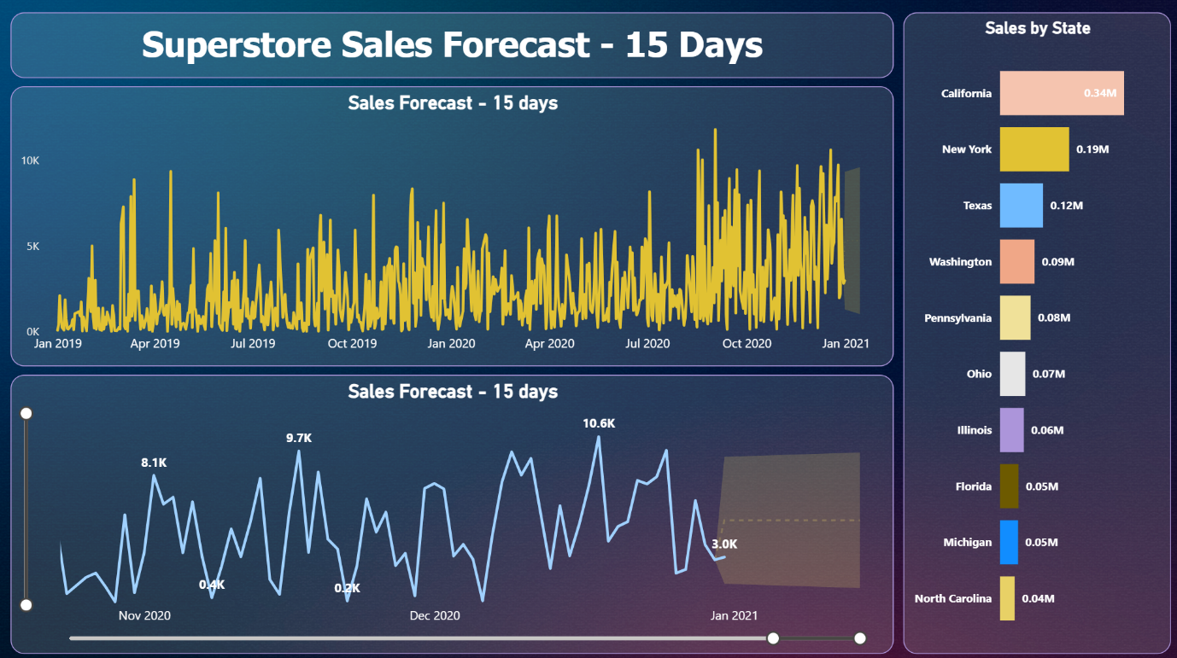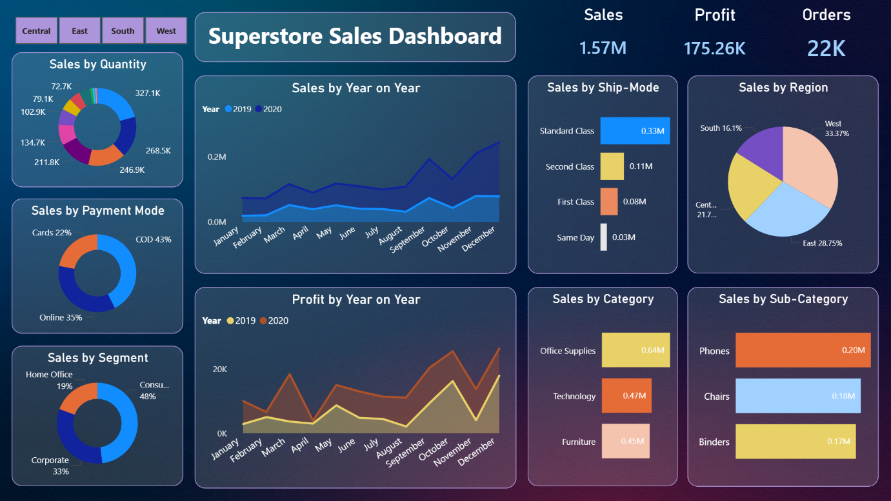

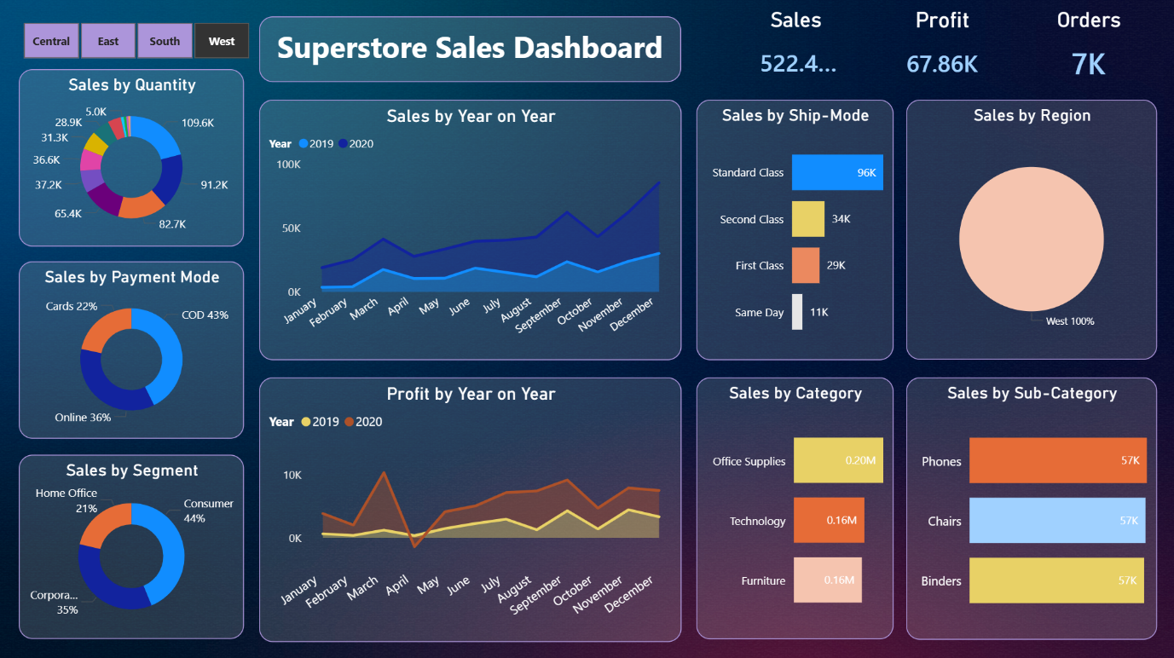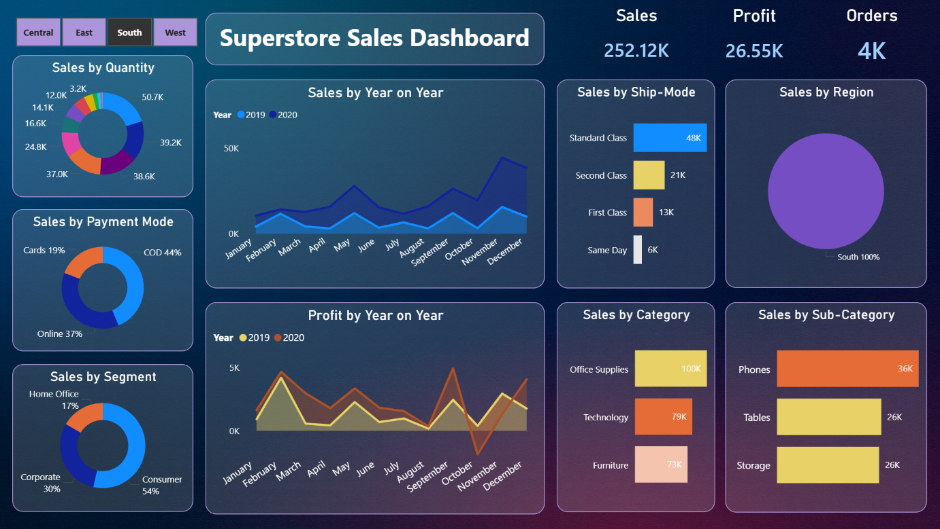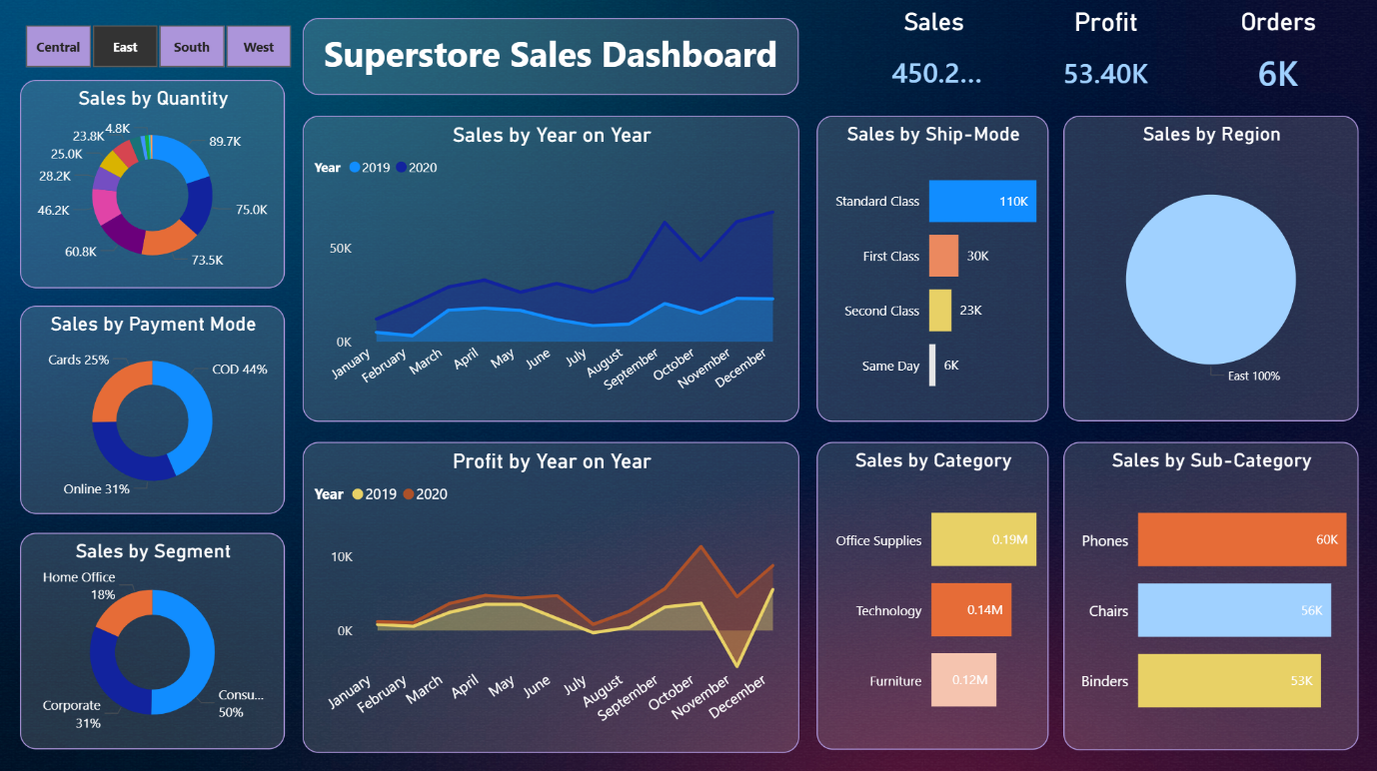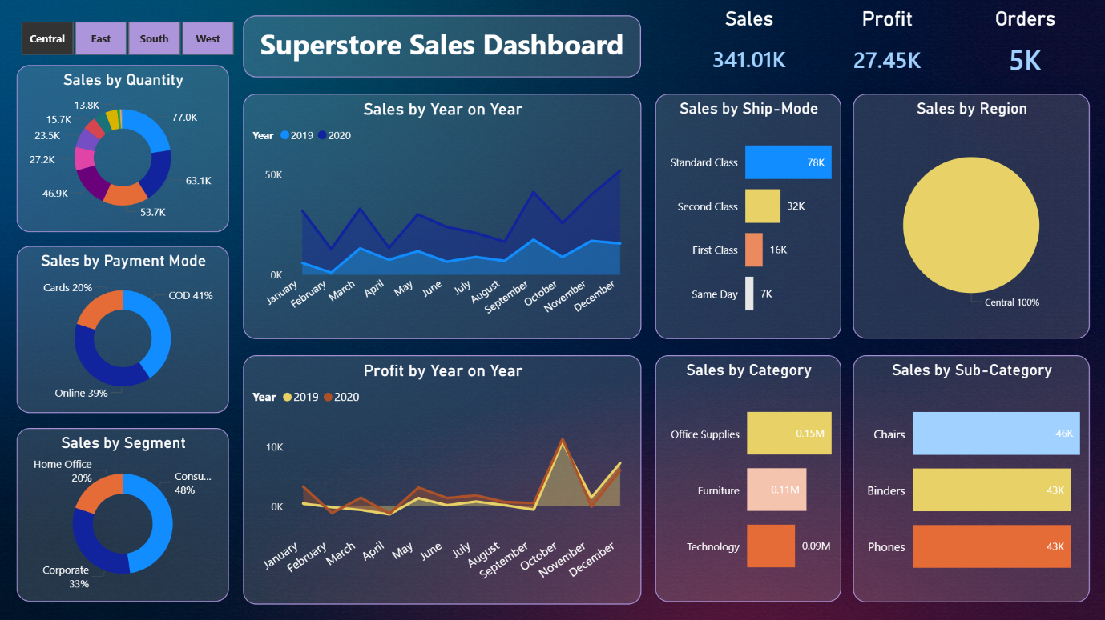

**Author**

Prathamesh Bhagwat, Future Interns Machine Learning Track (2025)  
For questions, contact: [pbhagwatphb@gmail.com]